KLAU’S FILM ASSOCIATION

PRESENTS

INTERNATIONAL PUPPET THEATRE FESTIVAL ALBANIA

“SKANDERBEG”

China Atlanta Romania Turkey Albania

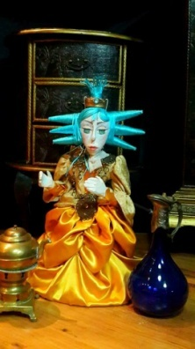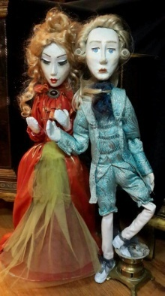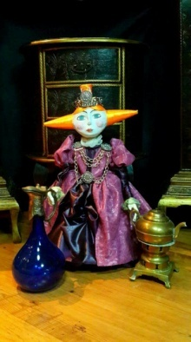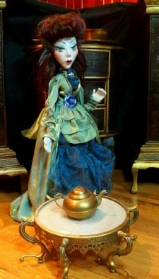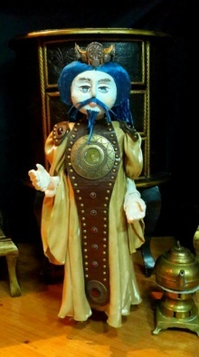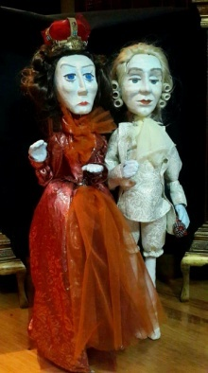

Approved and supported from

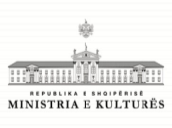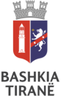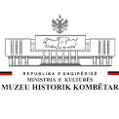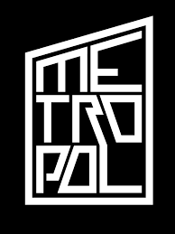

E-mail: klausfilmassociation@gmail.com

Project Description
International Puppets Theater Festival Albania "SKANDERBEG" will be a puppet theater festival with the most famous theatres’ troupes in this genre of art. This festival will be held for the first time in Albania and it is the only festival of this kind. It will offer to the public an extraordinary impact on the artistic cultivation and education which will directly affect the audience development. In addition, interest will be offered to interest groups in artistic circles as well as technical ones. The best troupes from different countries will bring their specific traditions in this very important confrontation of art. This festival will be annual with troupes participating from different countries. The festival will also have its own catalogue of 120 pages, where events with all the artistic, organizations, and the effects of this festival impact will be reflected. The bronze festival cup is another representative element, based on folk elements, but transformed into a global symbol, transmits a clear message on the philosophy of “Calling for equality and peace”.
Since 2018 has been announced as the year of Scanderbeg (our national hero) during the festival week, there will be a guide in tourist and historical places such as Kruja, Petrelë, Lezha etc . This festival will have a time span of 6 days. From different personal contacts and with the support of the respective embassies, among the best troupes with tradition in such a genre such as Romania, Atlanta (USA), China and Turkey have confirmed their availability. Troupes from Albania, Kosovo and Macedonia will be present as well. Each troupe will have two performances, and after each show, mini work-shops will be organized.
Every evening an artistic night with traditions from every participative country will be organized respectively. The night will be titled:
"Hello my name is: (............)"
This night will be accompanied by the culture and tradition of the respective country. In these festive nights on the monitors, there will be transmitted images of the history or architecture of the respective country, there will be live music from orchestras, traditional dresses and the rich culinary of that country. These nights will be organized in cooperation with the respective embassies. It will be an exchange of cultures and traditions among the participative countries of the festival. Culture and art unifies people with different history and languages.

This event, in cooperation and interaction with every relevant embassy, ​​based on a work done by our contacts with them, will bring a friendly spirit in the framework of peace, exchange and recognition of historical-cultural values ​​and traditions of different nations in one of the oldest countries in the world such as Albania. For 6 consecutive days it will be a marathon of shows and 6 festive evenings for each representative place. The final night, coincides with the 1-st of June the international children day. 3 shows in 3 different places and timetables in Tirana squares will take place. Celebrations from the Tirana traditional ensemble, children's group with folk costumes as an ensemble will donate a spectacle at the “Skanderbeg” Square. This final evening will be dedicated to the culture and traditions of the host country, Albania. In one of the squares of Tirana (New Bazaar) there will be music, poetry, culinary, ethnography from our hometown.
The final day of the festival will be:
Celebrations in the square, a tour visit from Tirana to the castle of Petrela, exhibition of the Albanian speaking troupe, Ethnographic exhibition by different authors from the Albanian-speaking lands at the National Museum, Exhibition of the Kosovo troupe, Parade of the children of Tirana together with the children of DSA with traditional clothing (Parade) and an awareness campaign for blood donation. Finally, the event of the Tirana troupe, next the closing of the festival together with the distribution of prizes and the Cup. Also, great closing party at the Folklore Ensemble Tirana, music, dance, poetry, traditional dishes from Albanian lands.

Project purpose:
- Establishing the first international puppet theater festival in Albania for children.
- Offering exchanges of experiences, cultures and traditions between different countries.
- Building communication bridges and international cooperation in order to create a dignified and welcoming atmosphere of a country with cultural heritage and traditions such as Albania.
- Promoting equality, peace, education and culture through the language of the beautiful art of puppet’s theater and all its gender and techniques.
- Building communication bridges for the exchange and recognition of the traditions and cultures of different nations

The Ministry of Culture has supported the Klau's Film Association in this project
Tirana’s Municipality also has supported the Klau's Film Association in this project

Metropol Theater & Cultural Center Tirana, has provided support and support to technicians, backgrounds, halls, etc ...
Digitalb as a dignified media partner for the whole event, where besides media advertising, it will engage in a wider coverage of the event, information, chronicle, reportage, etc.
The National History Museum has provided support and support to technicians, backgrounds, halls, etc ...

