CALL FOR PARTICIPATION;

INTERNATIONAL PUPPETRY FESTIVAL “IPfest2016” KENYA

“EYES ON KENYA”
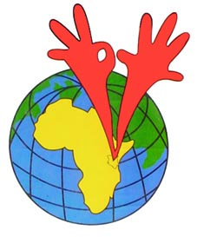
The Kenya Institute of Puppet Theatre (KIPT) is organizing the 8th International Puppetry Festival “IPfest 2016” Kenya which will be held from 15th to 22nd October, 2016 in Nairobi, Kenya.

The IPfest 2016 takes place against the background of the fundamental believe that “Cultural Diversity Through Art
Creates Peace, Unity, Harmony and Consensus”.

The theme is well thought out to contribute to peaceful 2017 general election in Kenya.

We invite you to this memorable event as we marks 22 years of the existence of community-based puppetry programs in Kenya.

This one week event will feature diverse performances in puppet/ mask/ object theatre, workshops and puppet theatre directors’ forums.

For more information on how to participate, visit www.ipfestivalkenya.org.

For any clarification contact;

Phylemon Odhiambo Okoth,
IPfest2016 Coordinator
info@ipfestivalkenya.org
info@kiptkenya.org
phylmono@gmail.com
+254 724 036 379

